**Certain ways to keep this forum clean.**

**Mention tags:**

1. **Reasoning :-** any fact deduced on your own thoughts and reasoning.
2. **Discussion :-** any topic of discussion
3. **Correction :-** any corrections in the content
4. **Fact/Good to know :-** any good intuitions noted
5. **Fun occurrences:** any funny things noted
6. Any further tags can be added with descriptions….

**Week** 2:

**Assignment** 2

**Discussion**:

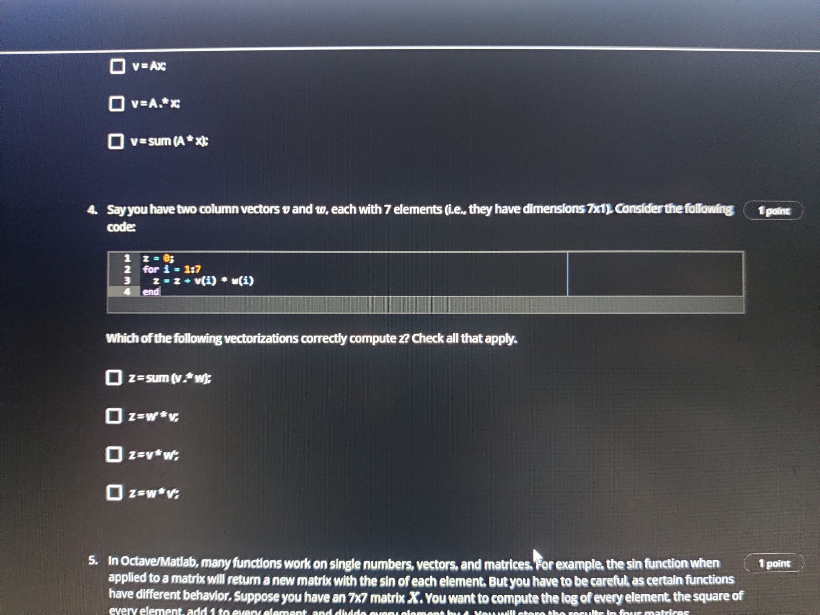I think the answer can be all four options. It was a wrong answer :( ..

**Week** 3: **Discussion:**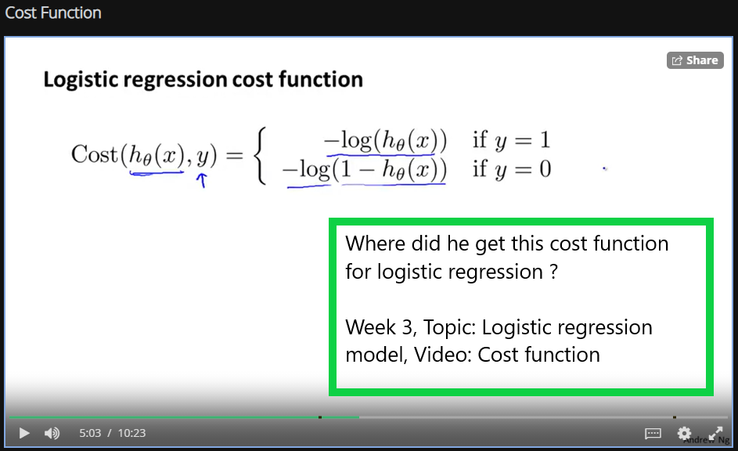

oukayy … in the later video, he has answered this and gave a justification for this Cost function.

“And why do we choose this particular function, while it looks like there could be other cost functions we could have chosen. Although I won't have time to go into great detail of this in this course, this cost function can be derived from statistics using the principle of **maximum likelihood estimation**. Which is an idea in **statistics** for how to efficiently find parameters' data for different models. And it also has a nice property that it is convex. So this is the cost function that essentially everyone uses when fitting logistic regression models. If you don't understand the terms that I just said, if you don't know what the principle of maximum likelihood estimation is, don't worry about it. But it's just a deeper rationale and justification behind this particular cost function than I have time to go into in this class.”

**Week** 3:

If someday we really sit down and try to find the equation of gradient descent for the logistic regression algorithm.

This is the partial derivative of J(theta) wrt theta.

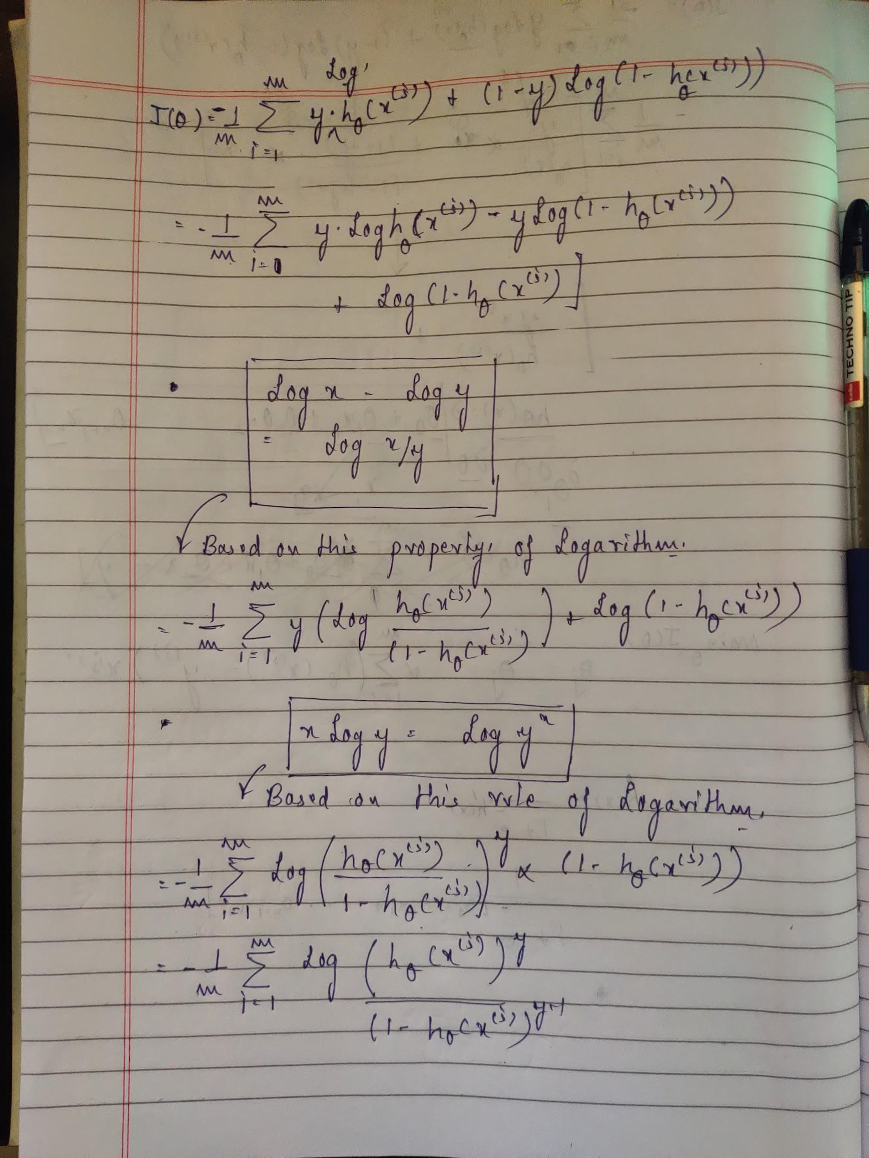

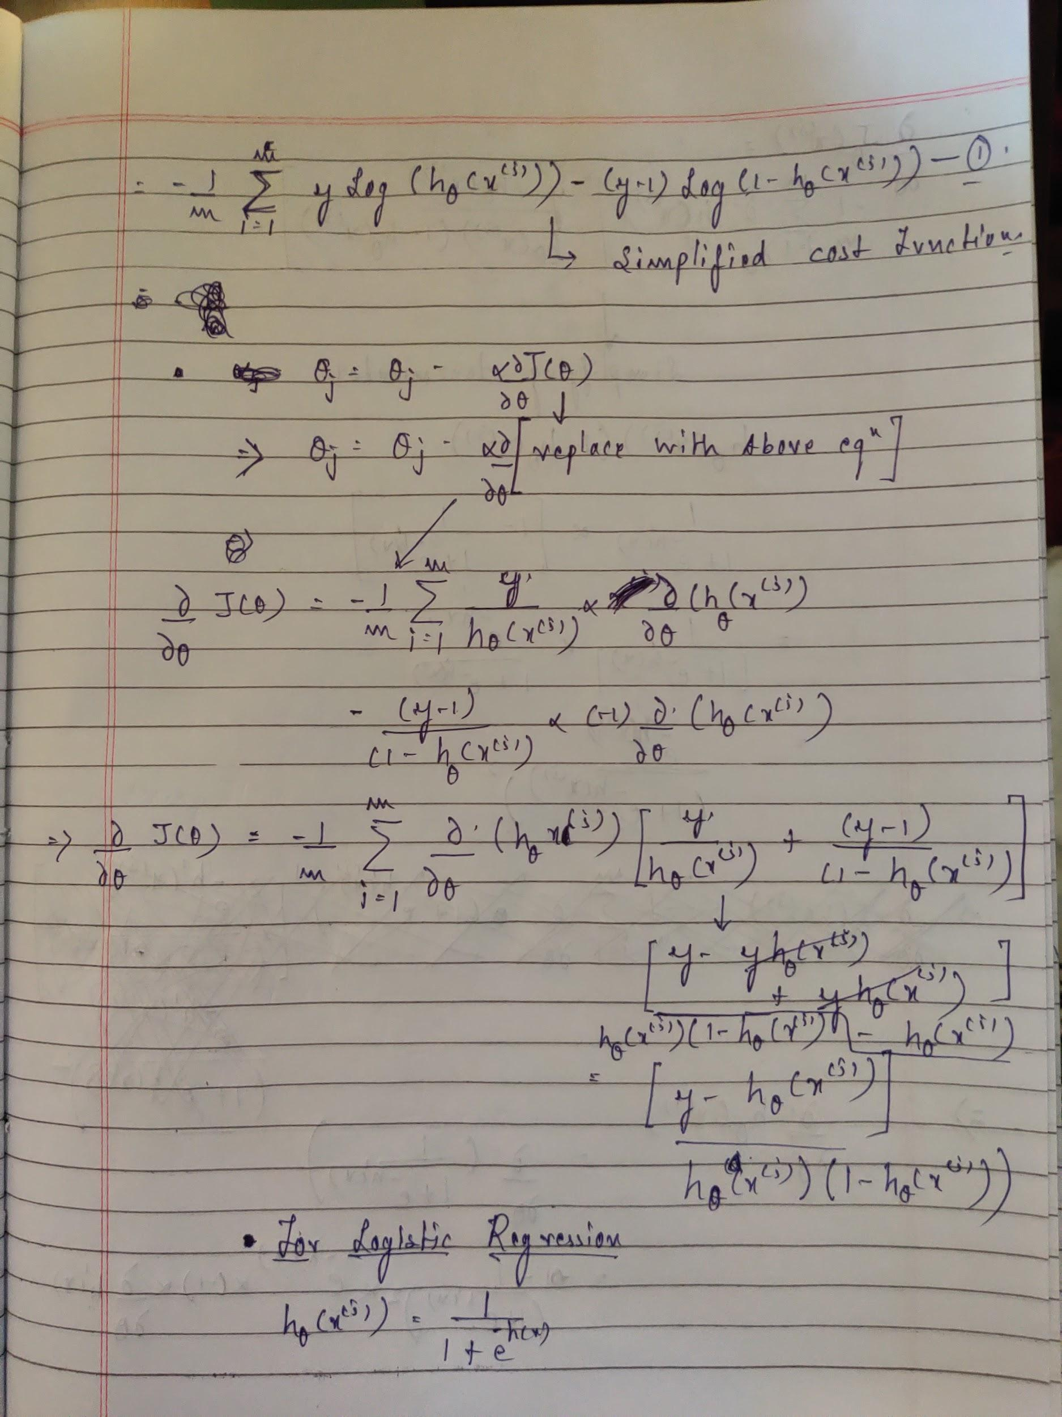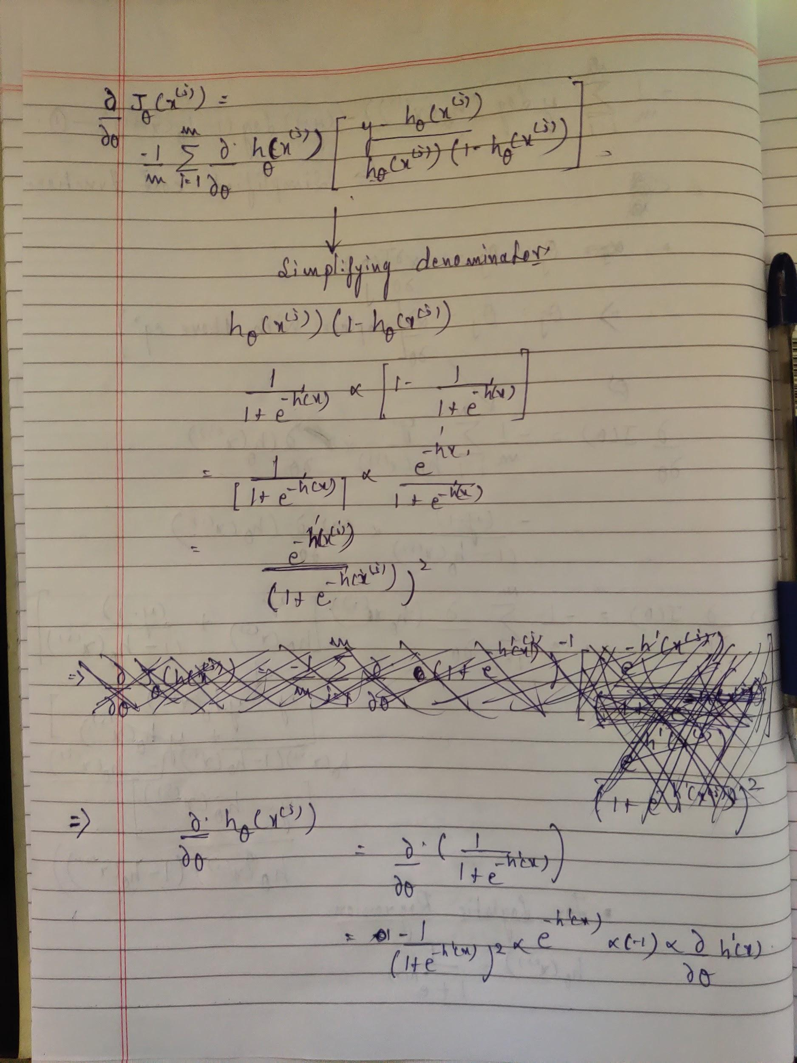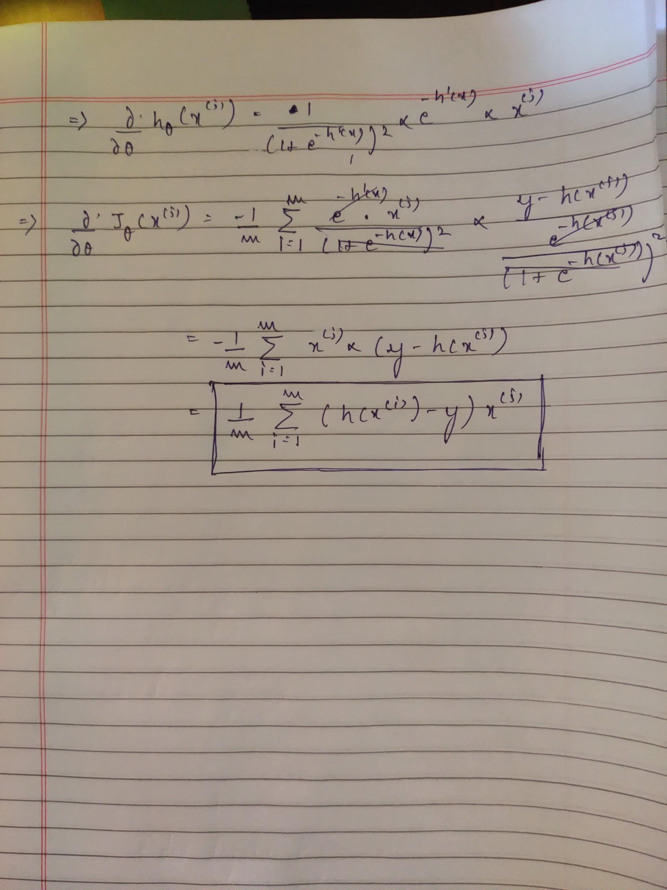

Some of the other computational methods to find out the minimum cost function parameters… They are beyond the scope of this course but we can probably take a look at this sometime in future..

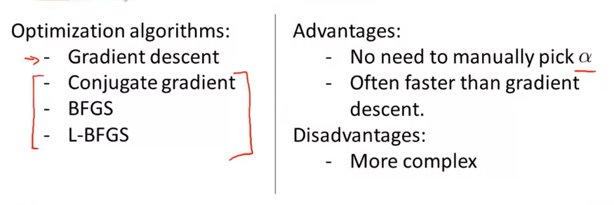

**Week** 3:

**Topic:** Solving problem of overfitting

**Discussion**: The idea of reducing the values of theta in order to regularize the learned model is justified. However the formula seems to be **adding (not subtracting)** to the cost function. I am not sure how this makes sense for now.

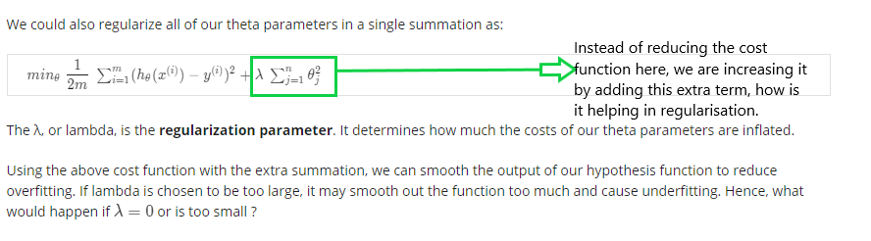

Uhhh, now I see….. Okay so increasing the cost function value will help in the gradient descent process.. It will reduce the value of theta more and more in subsequent iterations… The pink box formula is the partial derivative of the new cost function mentioned above.

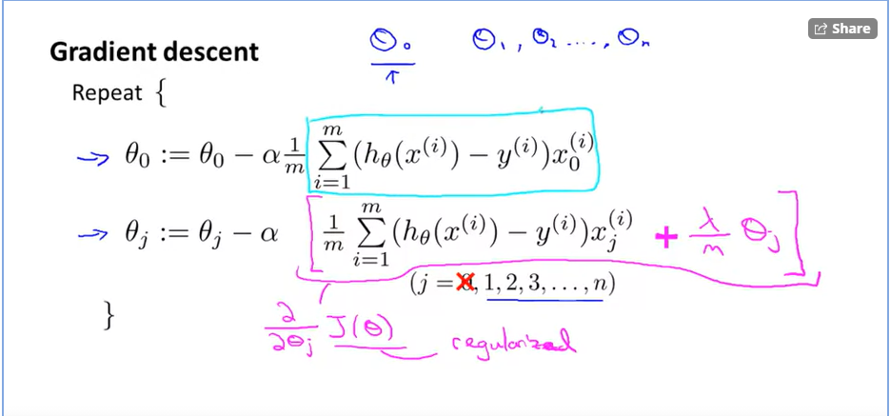

**Week** 3**:**

**Topic:** Regularisation of logistic regression.

**Reasoning fact/Discussion:**

For Advanced optimization functions, we don't need to select a value of "alpha" in the formula of gradient descent.

**Week** 3**:**

**Topic: Assignment** 2

**Discussion:**

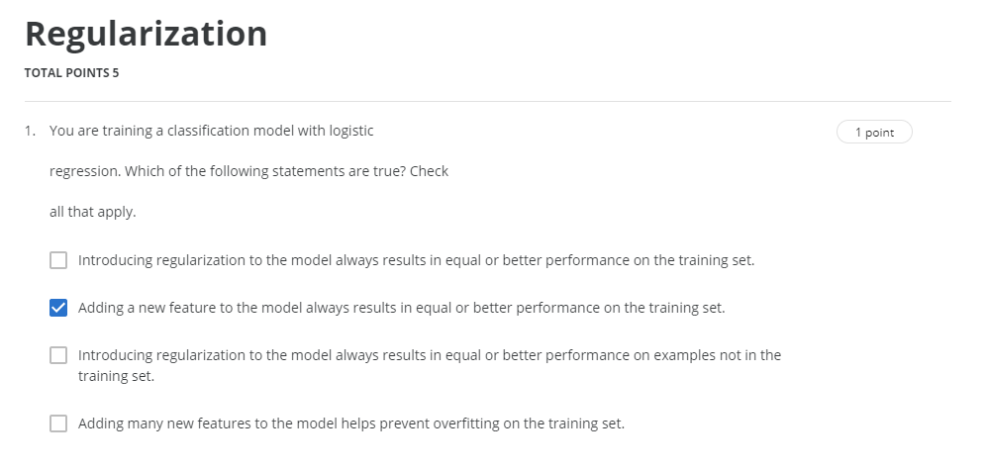

**Week 4:**

**Topic:** Examples and Intuitions II

**Discussion:**

In the video, at time 5:19, this is what he says

“And thus will this neural network, which has a input layer, one hidden layer, and one output layer, we end up with a nonlinear decision boundary that computes this **XNOR function**. And the more general intuition is that in the input layer, we just have our **four** inputs. Then we have a hidden layer, which computed some slightly more complex functions of the inputs that its shown here this is slightly more complex functions. And then by adding yet another layer we end up with an even more complex non linear function.”

If we consider the overall logic of the neural network.

there are 3inputs right ? not 4 no ?

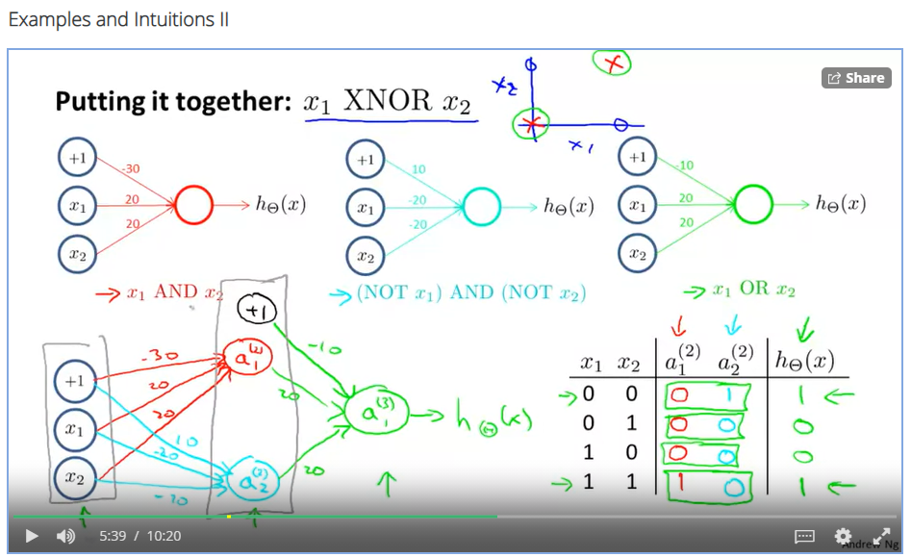

**Fact:**

Example of an XNOR truth table

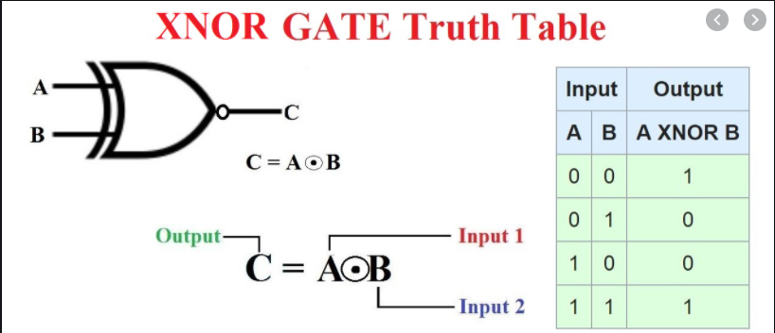

Oh achaaa.. 4 inputs in the logic table I think :thinking: :P

**Week** 4:

**Assignment** 1:

**Discussion**

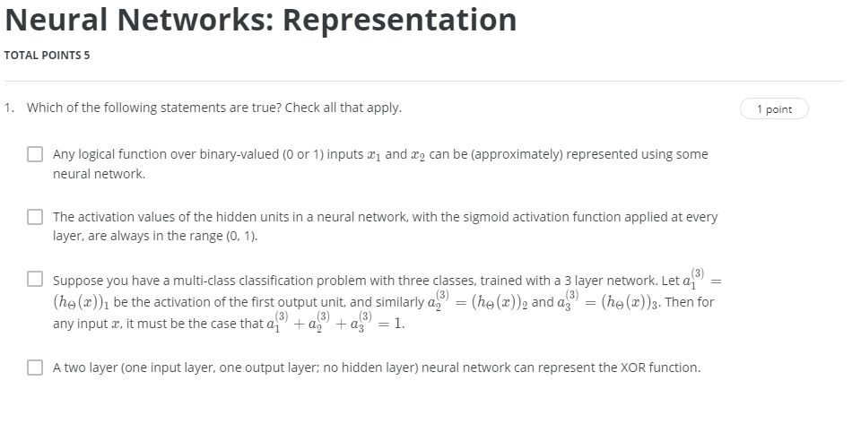

**Week 5:**

**Topic:** Neural network and cost function.

**Discussion:**

As we know one layer in the neural network serves as a feed to the next layer. But at times we see the number of units in a layer decreases as we go forward in the network. What decides this ?

It is somewhat explained later in this week, seems like an architectural choice

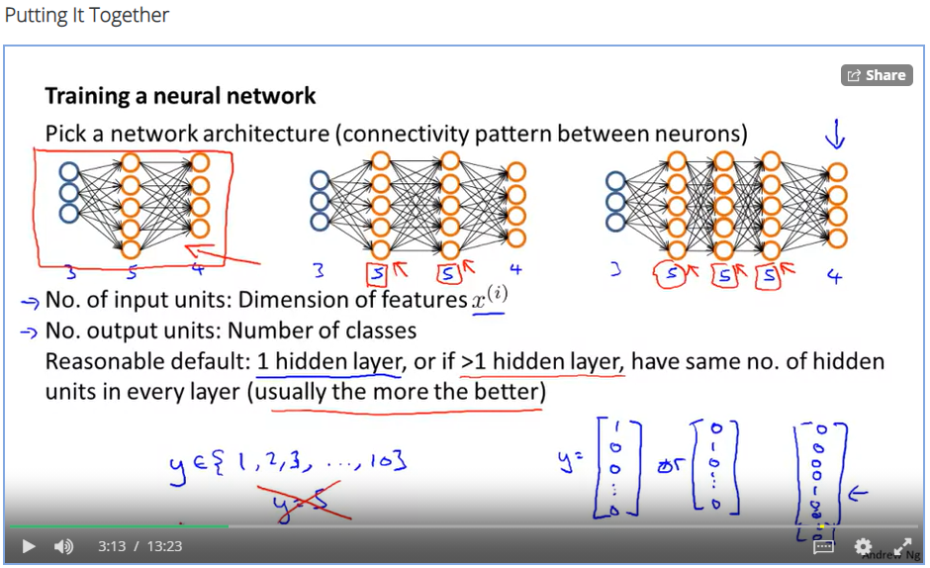

**Week 5**:

**Topic**: Back propagation Algorithm

**Discussion:**

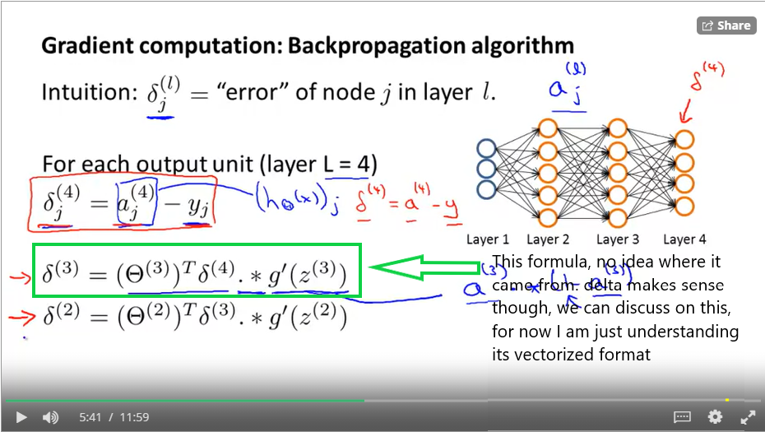

**Week** **5**:

**Discussion**:

In the lecture "Backpropagation algorithm, formula for calculating \delta for any layer is given as \delta^{(l)} = ((\Theta^{(l)})^T \delta^{(l+1)})\ .*\ a^{(l)}\ .*\ (1 - a^{(l)})δ(l)=((Θ(l))Tδ(l+1)) .∗ a(l) .∗ (1−a(l))

Going ahead in lecture "Backpropagation Intuition", while calculating delta for any index in a layer, we used the formula, for ex: δ2(2)​= \Theta_{12}^{(2)}Θ12(2)​*\delta_1^{(3)}δ1(3)​+\Theta_{22}^{(2)}Θ22(2)​*\delta_2^{(3)}δ2(3

I see we are missing ∗ a(l) .∗ (1−a(l)) term in the later. I am a little confused here.

I have raised a query in the forum also for this.

<https://www.coursera.org/learn/machine-learning/discussions/weeks/5/threads/tn2BtwSCEeuMoRIkdXohpw>

Aaah ! A mentor replied…

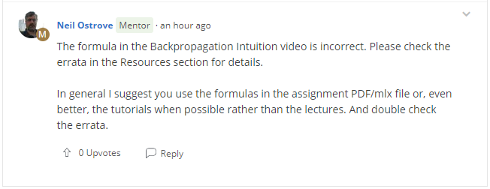

**Week 5**:

**Discussion:**

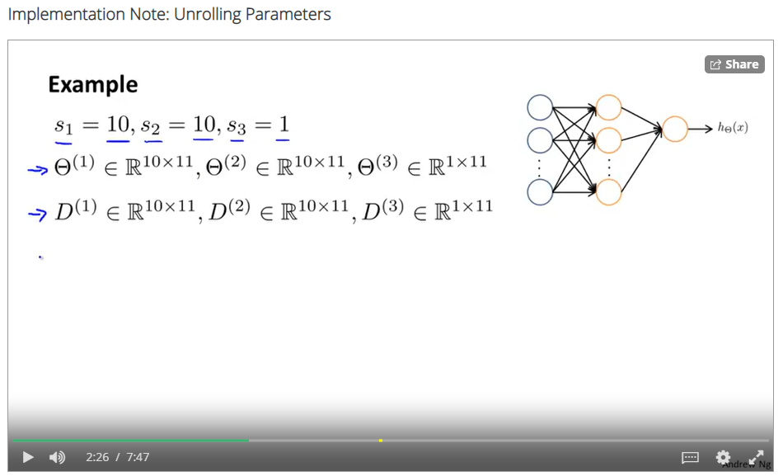

Is the dimensions of theta matrices correct ? According to the given neural network.

I think all are hidden layers, they haven’t shown the feature layer.

**Week** **5**:

**Discussion/Quiz**:

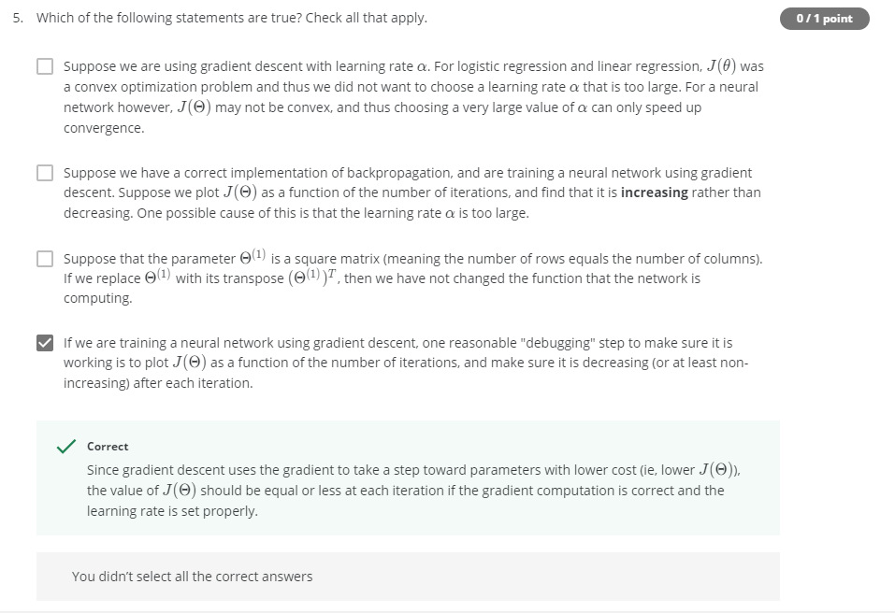

I think option 1 should also be an answer though.

**Week 5**:

**Fact/Assignment:**

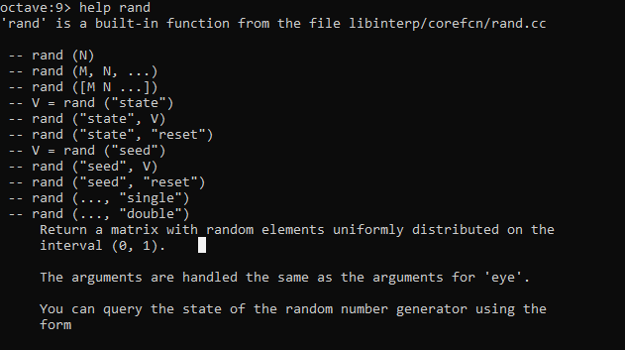

This can be helpful that “rand” function generated random numbers between **0 and 1**.

**Week 6:**

**Summary/Facts:**

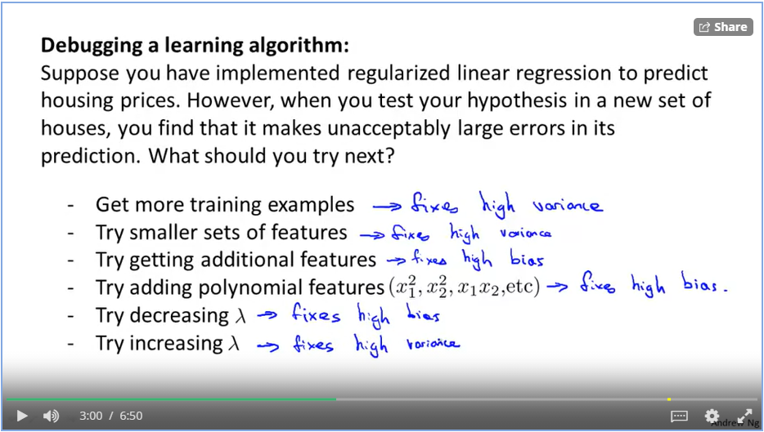

This is all suggested by the legend ( :p ) to increase the performance of a learned model.

**Week 6:**

**Discussion:**

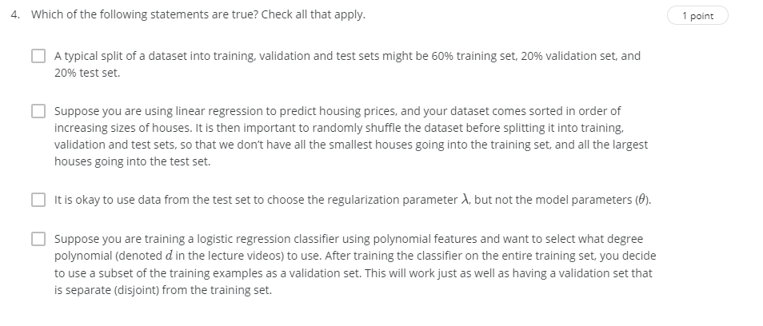

**Week 6**

**Discussion:**

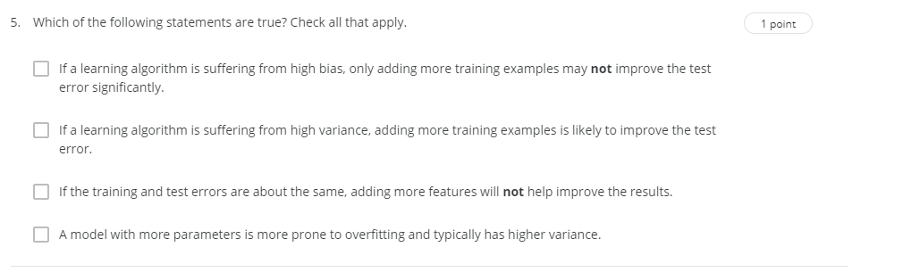

**Week 6:**

**Help Fact:**

Seems like there are certain unnecessary warnings given by the latest octave which is making the assignment submit a failure. The score is graded by string to string match it seems.

Somewhat the errors are like this

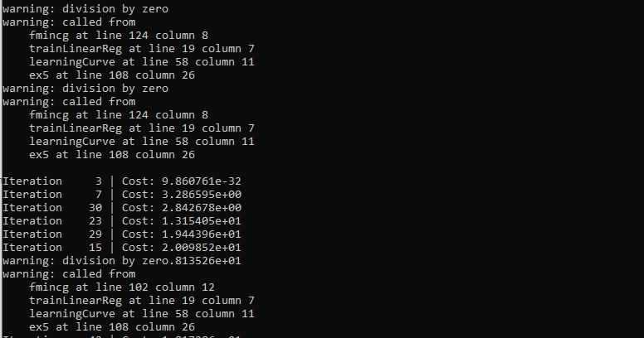

Use this warning('off', 'all');

I have come to a realisation that sum function has too much precision in decimal places. the test cases in this course are solved by the moderators using normal matrix operations (multiplication, addition, subtraction etc). This makes minor disparity in the results and the grade system fails to accept our solutions. Try to avoid sum function in Octave.

**Week 6:**

**Fun fact:**

Just while reading through the docs of week 6. I found this



I think this company MuSigma is named after this idea !! oooh bitches didn’t use brains to name their company !!

**Week 6:**

**Discussion:**

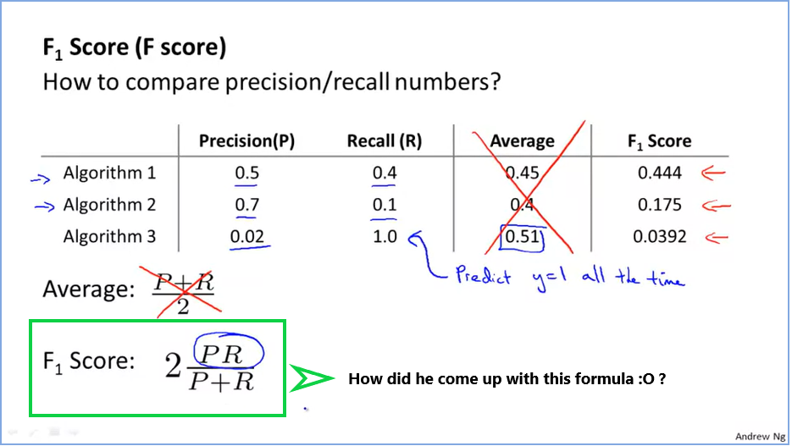

**Week 6:**

**Fun fact:**



No wonder, stupeeds become data scientists these days !! ex: **Ankit Singh**

**Week 6:**

**Fact:**

Sometimes because of lack of supporting features for prediction. The algorithm performance goes down. So everytime it is good to question that, “whether a human expert can make proper predictions if given with a similar set of features ? “

If the features are inadequate with their providing features, then even neural networks might fail in giving a good prediction.

**Week 7:**

**Discussion:**

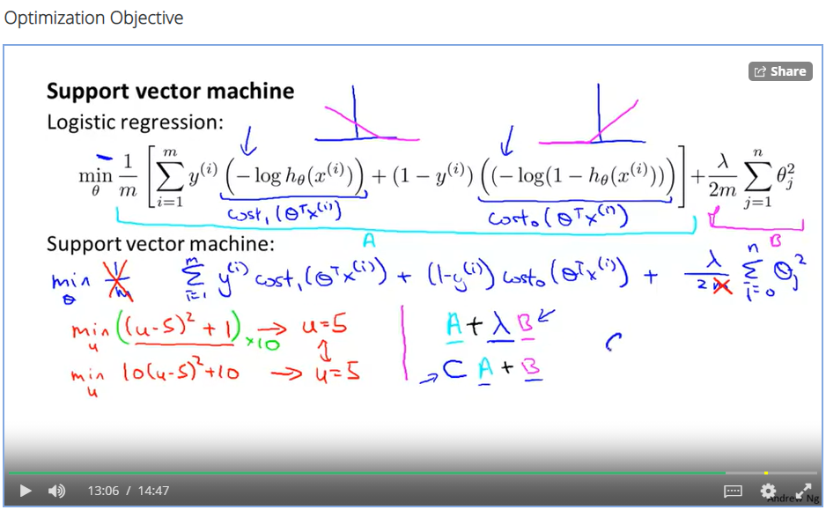

Sometimes he makes formulas from air ! CA+B where did the lord bring this from ? this time it not making sense also..

**Week 7:**

**Discussion:**

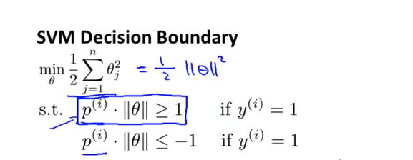

How did he decide that the SVM should consider h(z) = 1 with z > 1 and h(z) = 0 with z < -1, Like it can be 2 and -2 or 1 and -2. Any ideas behind this inference ?

**Week 7:**

**Discussion:**

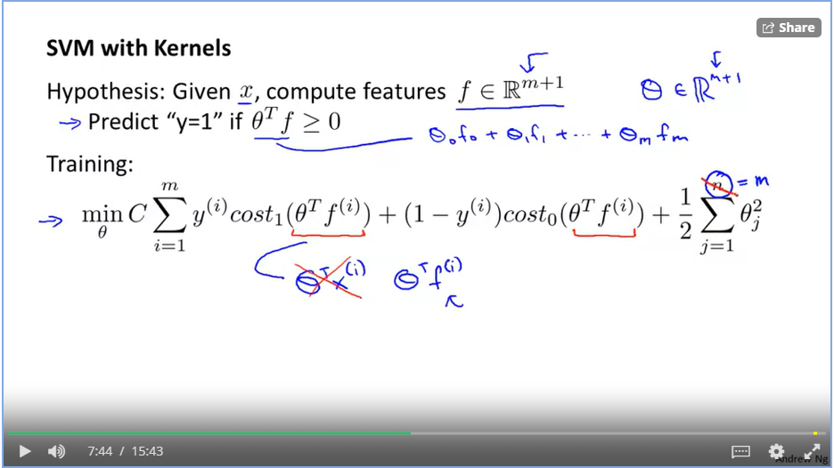

Now for applying kernel’s in SVM, we just have to replace theta(T).X by Theta(T).f . However if we remember if theta(T).X > 1 then we take H(theta) = 1 by Cost(1) and H(Theta) = 0 if theta(T).X < -1, after replacing X with f (Similarity terms) min f value can be is 0 and max can be is 1, how is it going to work now ?

**Week 7:**

**Discussion:**

The lord mentions in Kernel II lecture this

“And one last detail is because this optimization problem we really have n equals m features. That is here. The number of features we have.”

How come n = m here ?

:O

**Week 7:**

**Fact/Good to know:**

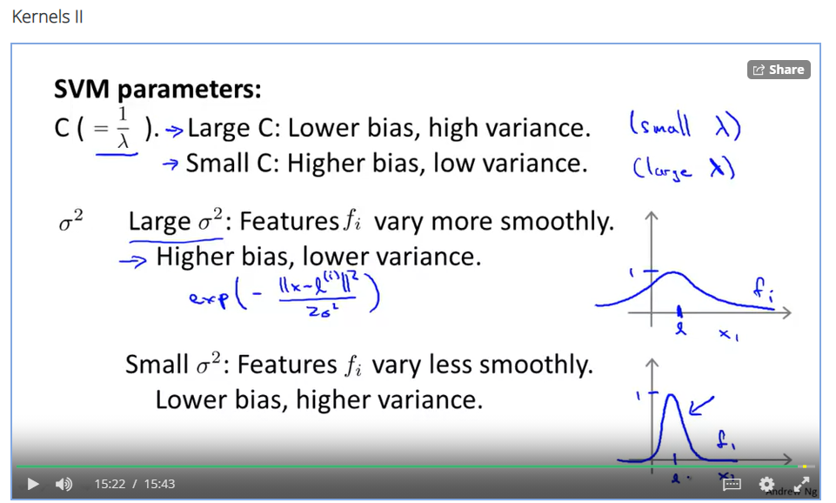

**Week 7:**

**Fact/Good to know:**

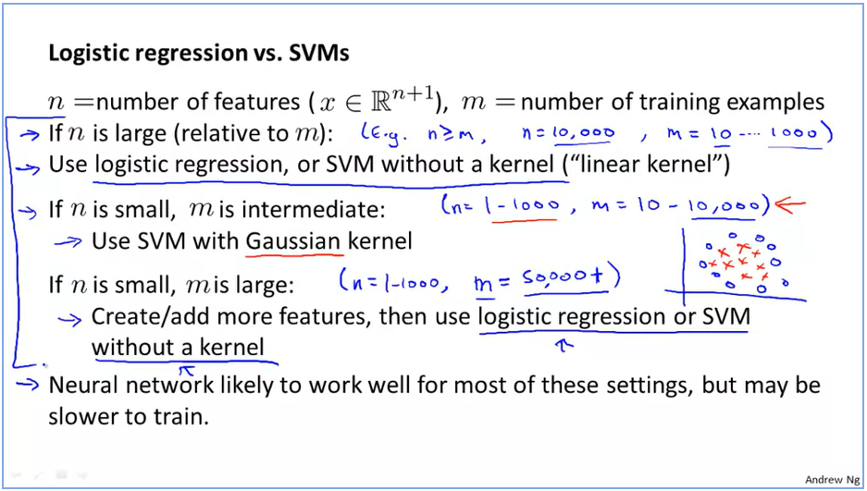

**Week 7:**

**Discussion:**

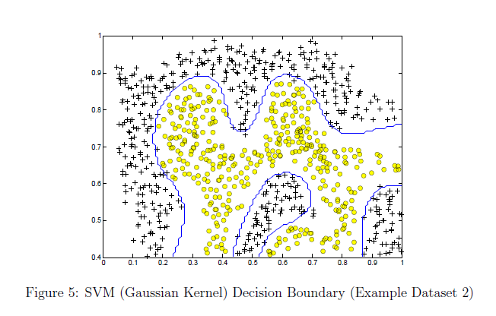

With the usage of Gaussian kernel in SVM, we are able to make non linear classification such as above. How is the implementation of such a kernel making such nonlinear classification ?

**Week 8:**

**K Means Algorithm:**

**Fact/Good to know:**

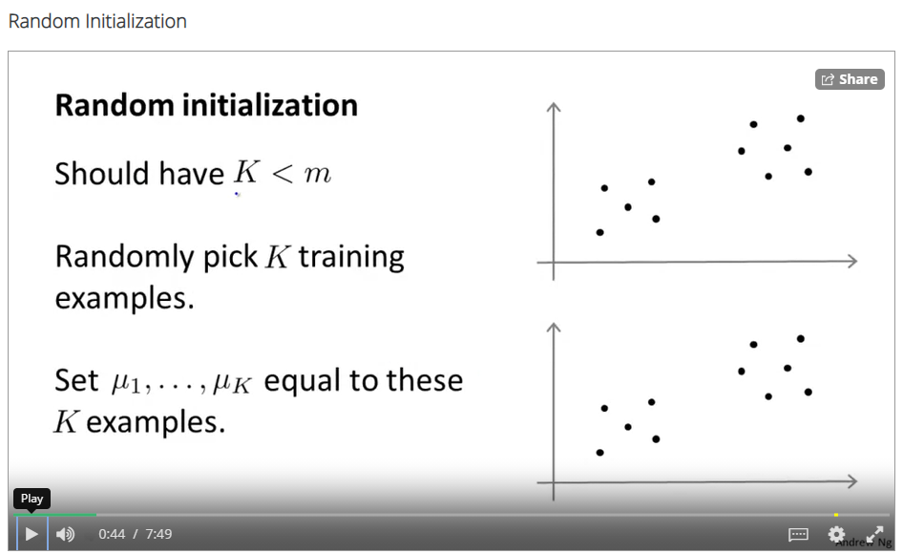

**Week 8:**

**K Means Algorithm**

**Lol realisation:**

So says the lord: “So, instead of just initializing K-means once and hopping that that works, what we can do is, initialize K-means lots of times and run K-means lots of times, and use that to try to make sure we get as good a solution, as good a local or global optima as possible.”

**Week 8:**

**K Means Algorithm**

**Fact/Good to know:**

“And it turns out that if you are running K-means with a fairly small number of clusters , so you know if the number of clusters is anywhere from two up to maybe 10 - then doing multiple random initializations can often, can sometimes make sure that you find a better local optima. Make sure you find the better clustering data. But if K is very large, so, if K is much greater than 10, certainly if K were, you know, if you were trying to find hundreds of clusters, then,

Play video starting at :6:45 and follow transcript6:45

having multiple random initializations is less likely to make a huge difference and there is a much higher chance that your first random initialization will give you a pretty decent solution already

Play video starting at :6:56 and follow transcript6:56

and doing, doing multiple random initializations will probably give you a slightly better solution but, but maybe not that much. But it's really in the regime of where you have a relatively small number of clusters, especially if you have, maybe 2 or 3 or 4 clusters that random initialization could make a huge difference in terms of making sure you do a good job minimizing the distortion function and giving you a good clustering. “

**Week 8:**

**Fact/Good to know**

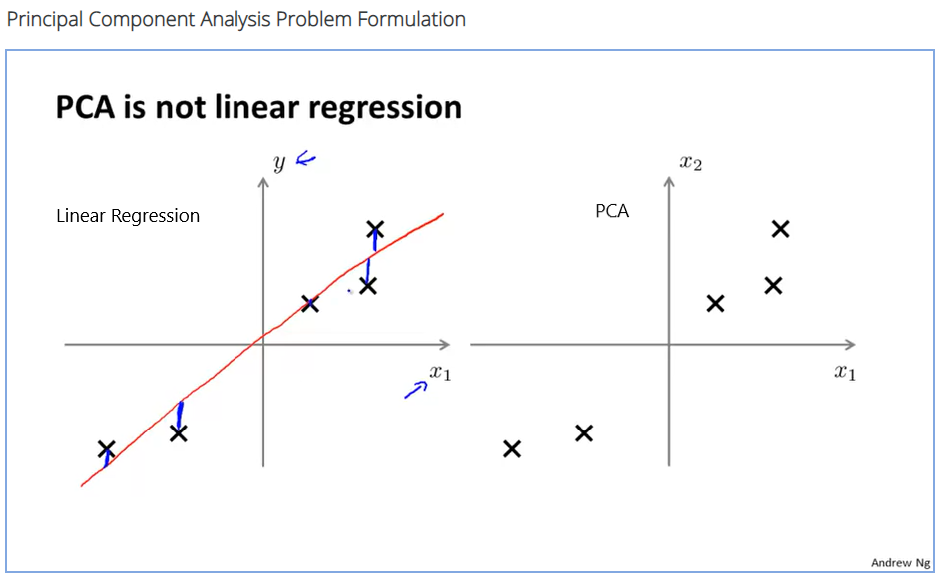

**Week 8:**

**Fact/Good to know**

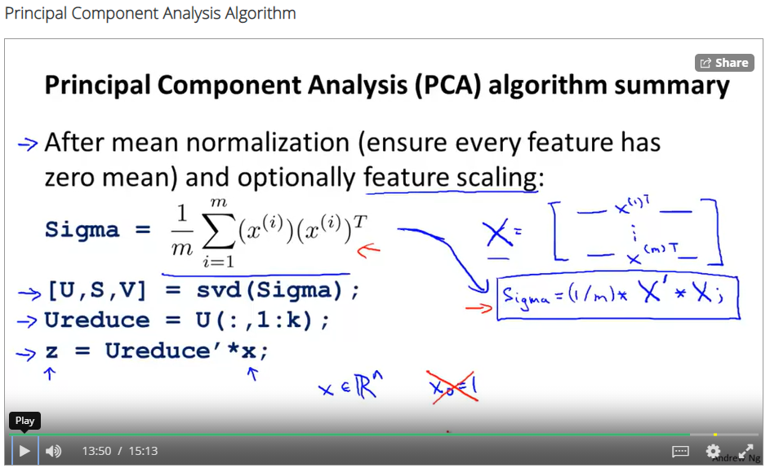

PCA algorithm implementation in short

**Week 8:**

**Fact/Good to know:**

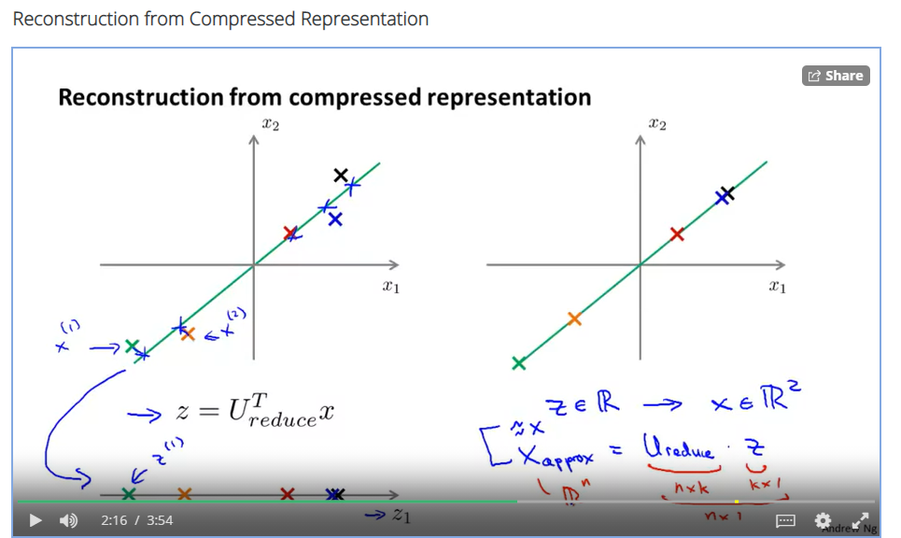

To extract X values back from Z values.

**Week 8:**

**Discussion:**

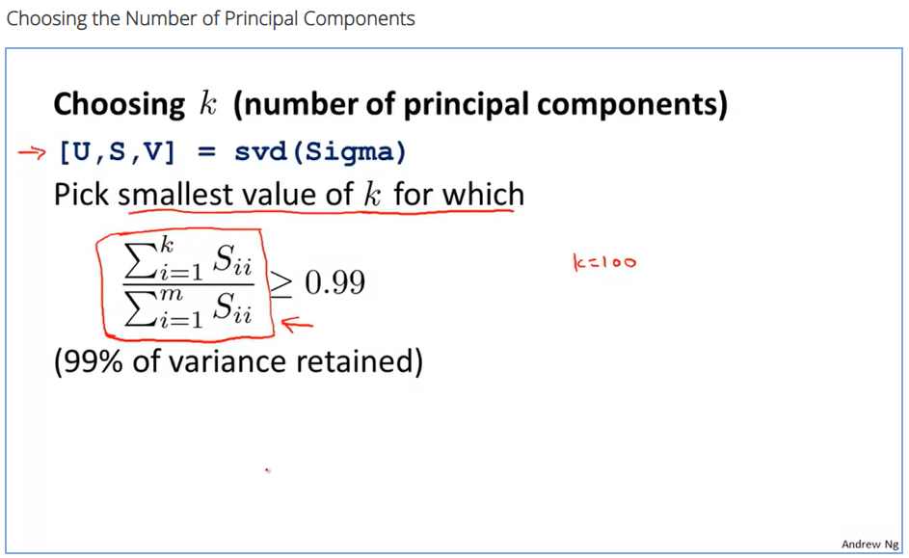

What exactly is this S value from the svd function ?

This S value helps in determining an appropriate k value for compression.

**Week 8:**

**Fact/Good to know:**

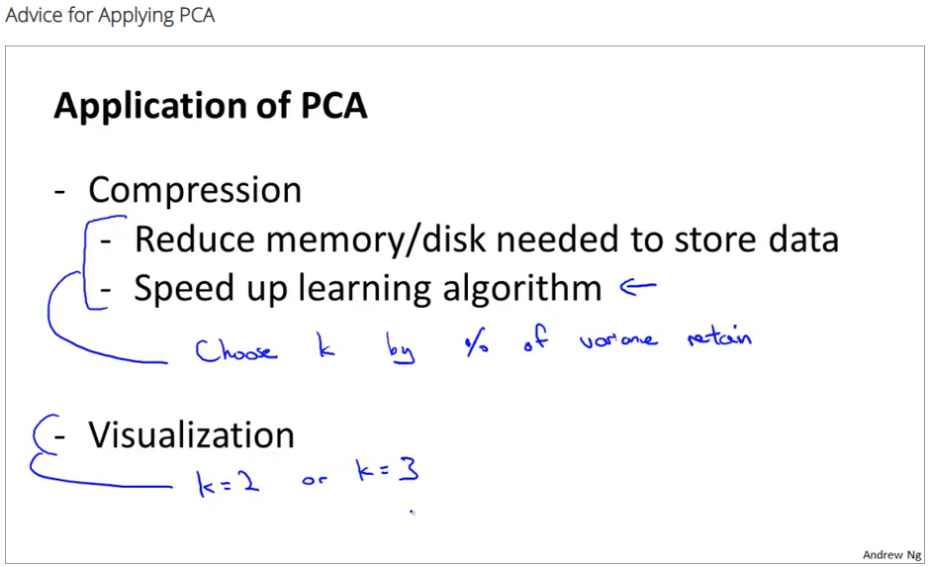

**Week 8:**

**Fact/Good to know:**

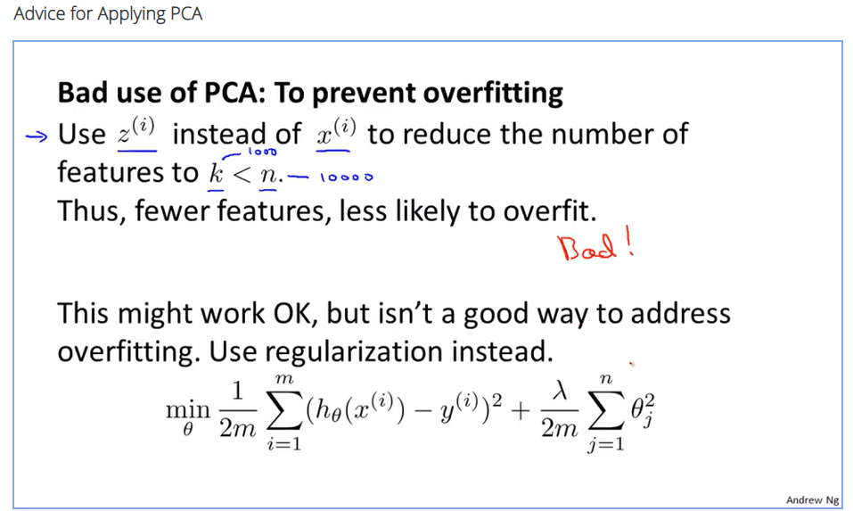

So says the lord !! :P

**Week 8:**

**Correction:**

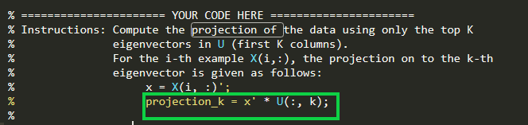

In the assignment for week 8, projectData.m, There is a small mistake in the suggestion of the approach for projection formula in octave syntax, it should be U(:, 1:K) and U(:, k); . using the later passes the in exercise test cases but fails during submission. I think they did it purposefully may be :thinking:

**Week 9:**

**Fact/Good to know:**

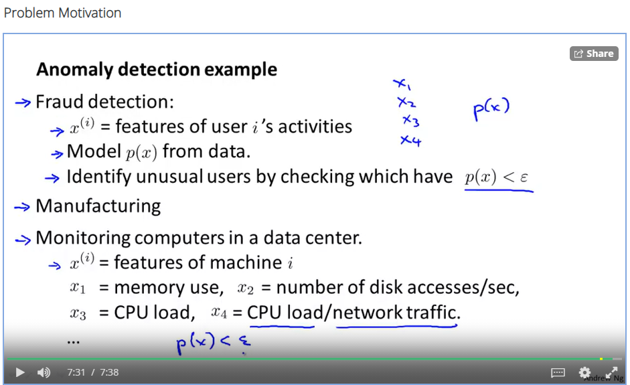

**Week 9:**

**Fact/Good to know:**

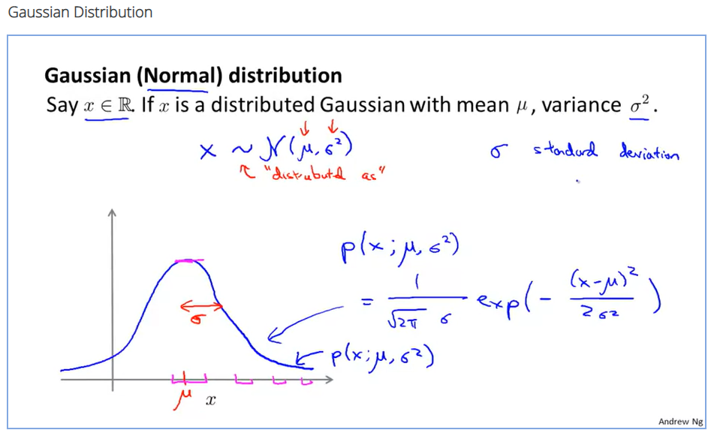

I remember studying this in university.. :nostalgia: :P

**Week 9:**

**Fact/Good to know:**

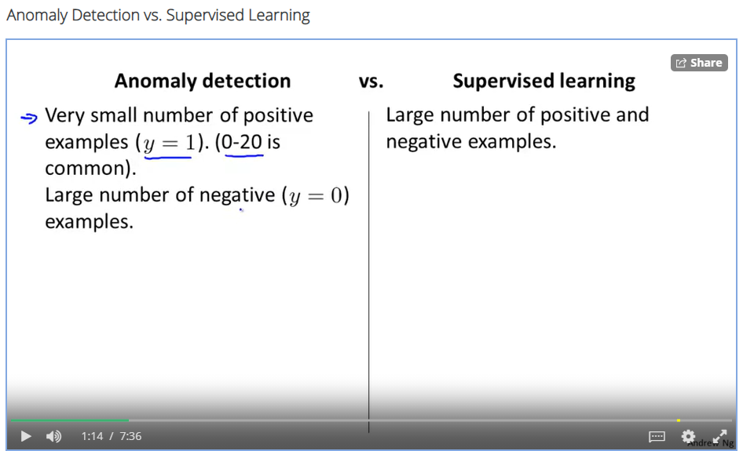

Positive examples can be said as anomalies. Like the number of faulty pieces of aircraft.

**Week 9:**

**Fact/ Good to know:**

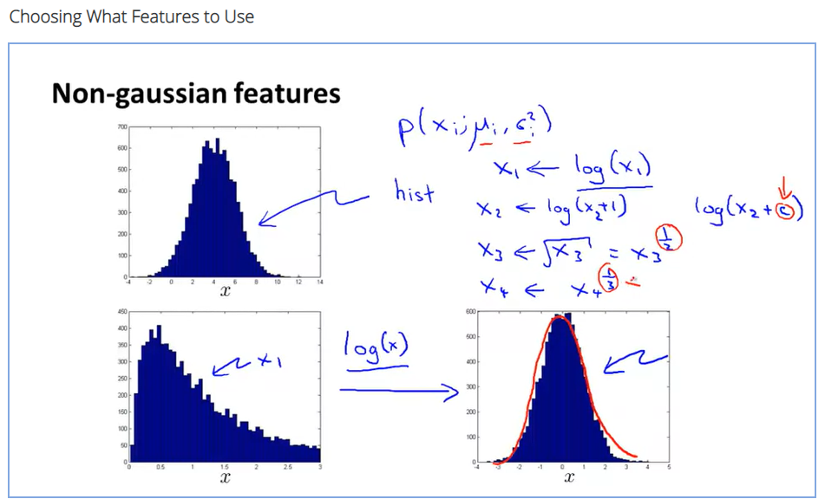

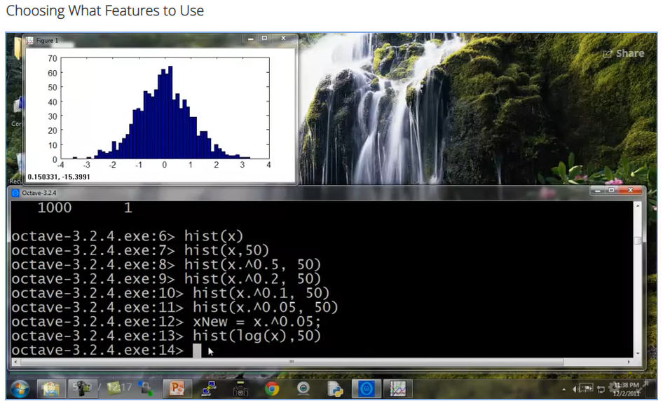

To make data fit into a Gaussian format. Use certain mathematical manipulations to fit into the curve. We just have to hit and try various combinations with the dataset.

**Week 9:**

**Fact/good to know (from optional learning part)**

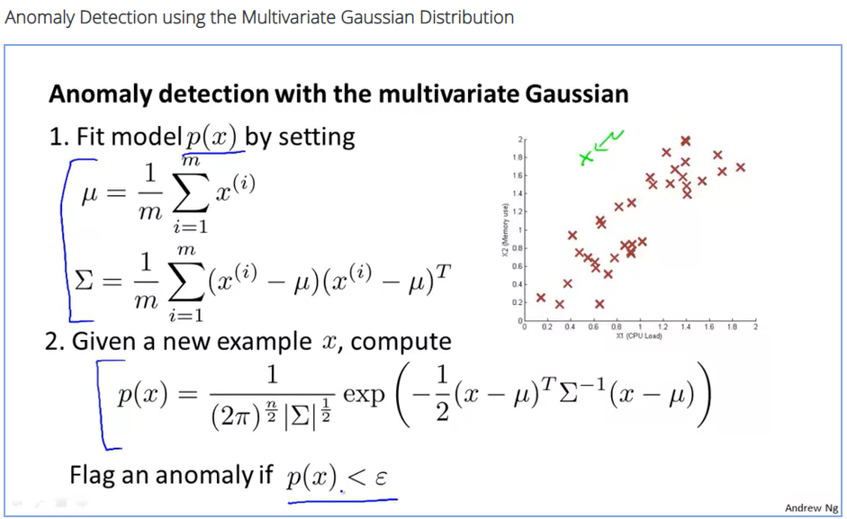

Formulae to calculate mu and sigma values in case of multivariate gaussian distribution.

**Week 9:**

**Fact/good to know:**

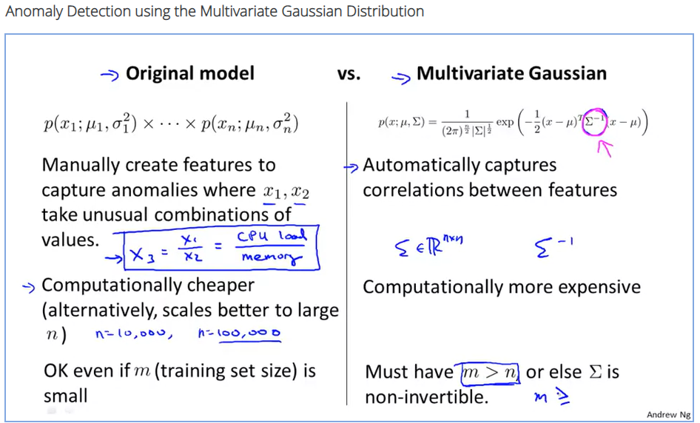

**Week 9:**

**Discussion:**

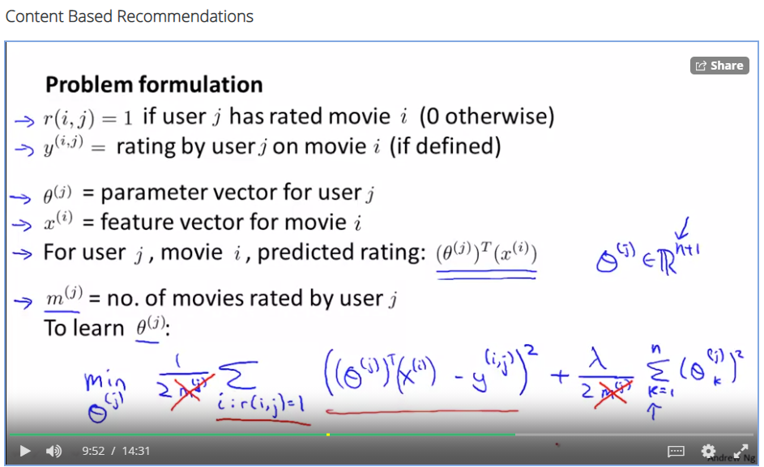

What exactly are the features and the targets for a user training in case of the above example for training ?

**Week 9:**

**Fact/Good to know:**

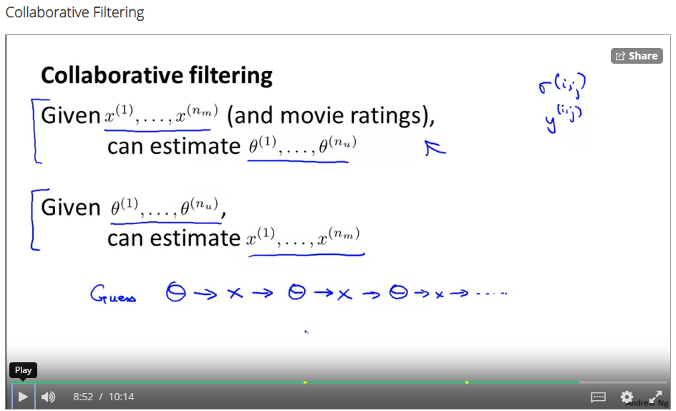

**Week 9:**

**Fact/Assignment:**

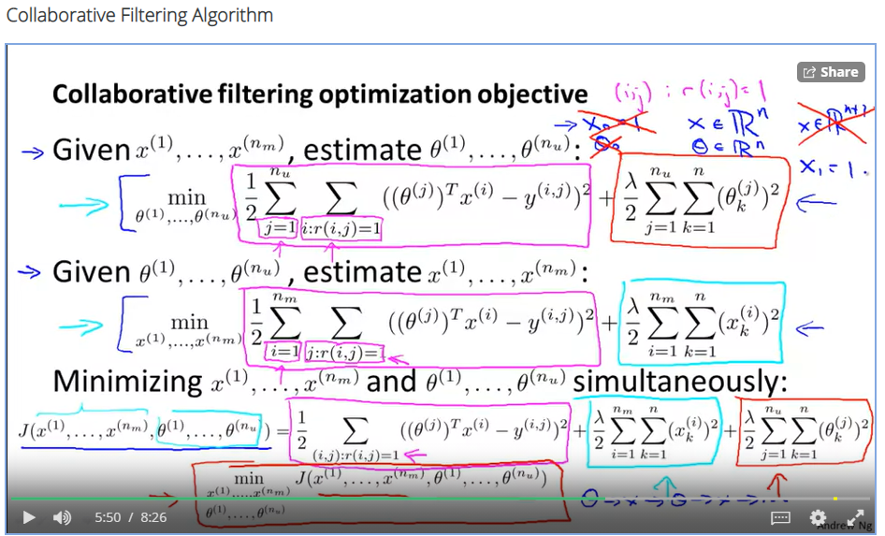

We don’t need a bias term in the case of this learning model, as we are learning x and theta both here, adding “1” bias term seems unnecessary.

**Week 9:**

**Fact/Good to know:**

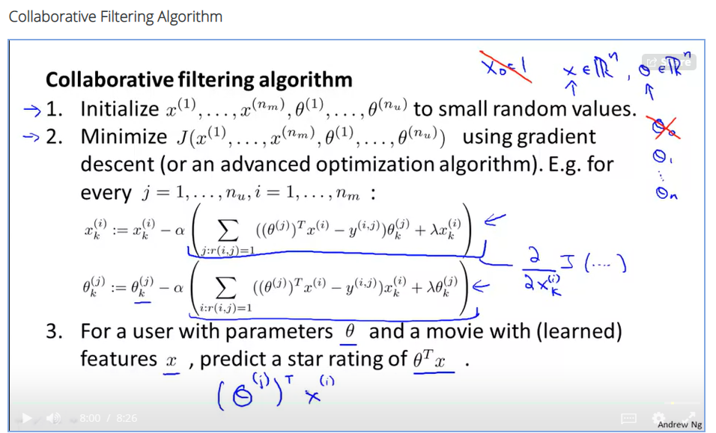

I imagine how much of computational power this type of learning will take. The movie recommendations we get is damn costly job :P

**Week 9:**

**Fact/ Good to know:**

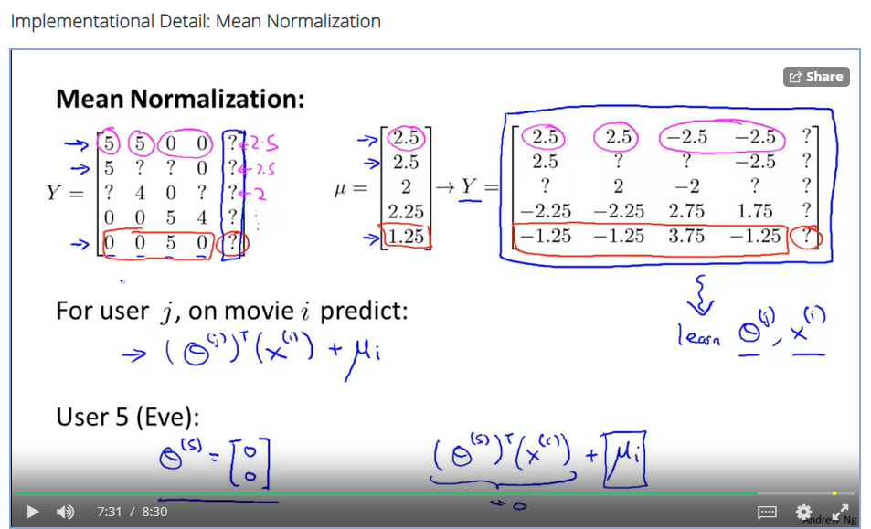

How we predict initial y values of a user who has not shared a single review. We follow the mean normalisation value. This gives an intuition that we assign a new user values derived from existing ratings.

**Week 10:**

**Discussion:**

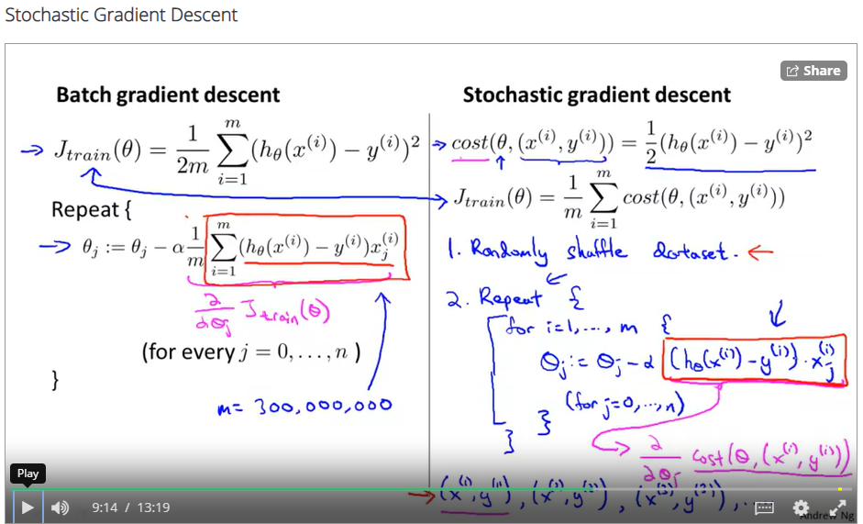

Apparently, The lord says stochastic gradient descent is faster but i have a feeling that it will also take the same time.

**Week 10:**

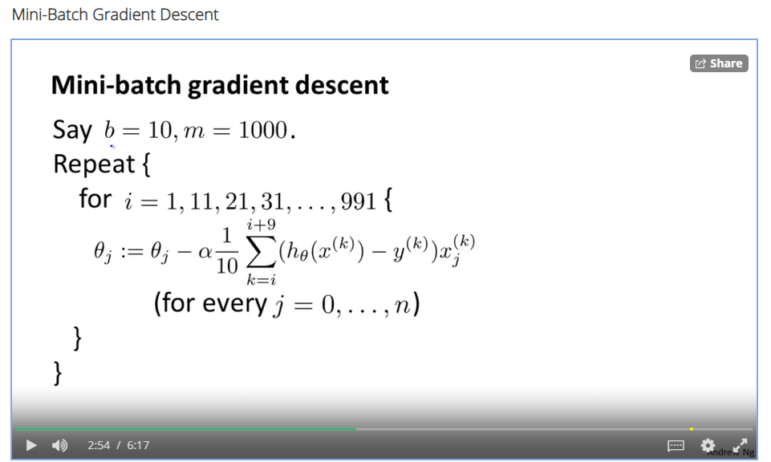

Here instead of taking the whole training set, we just take a batch of training sets.

**Week 10:**

**Fact/Good to know:**

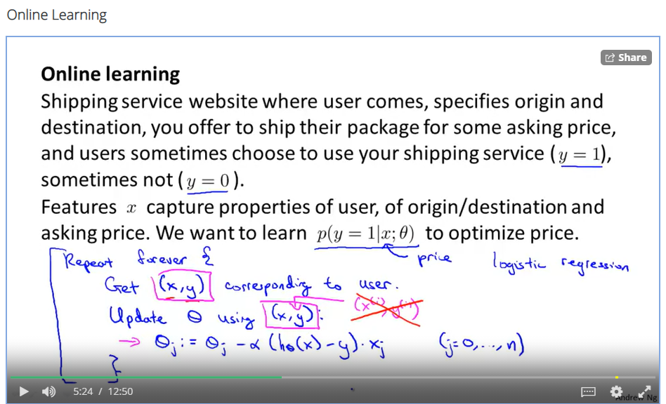

This looks sort of a progressive learning as the datasets are asynchronously keep coming through an online feed or streaming service. We learn the theta and discard that particular dataset. Cool tech !

**Week 10:**

**Fact/Good to know:**

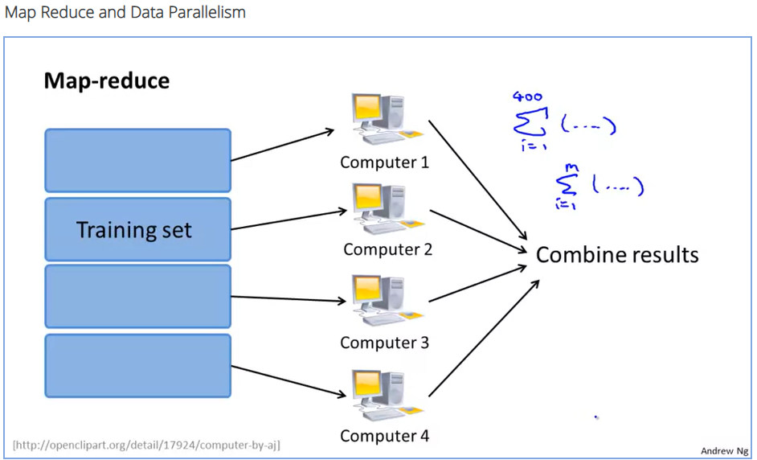

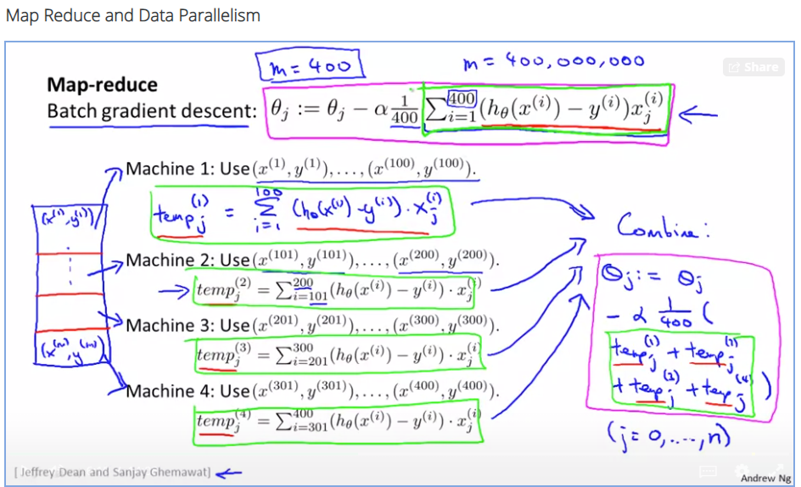

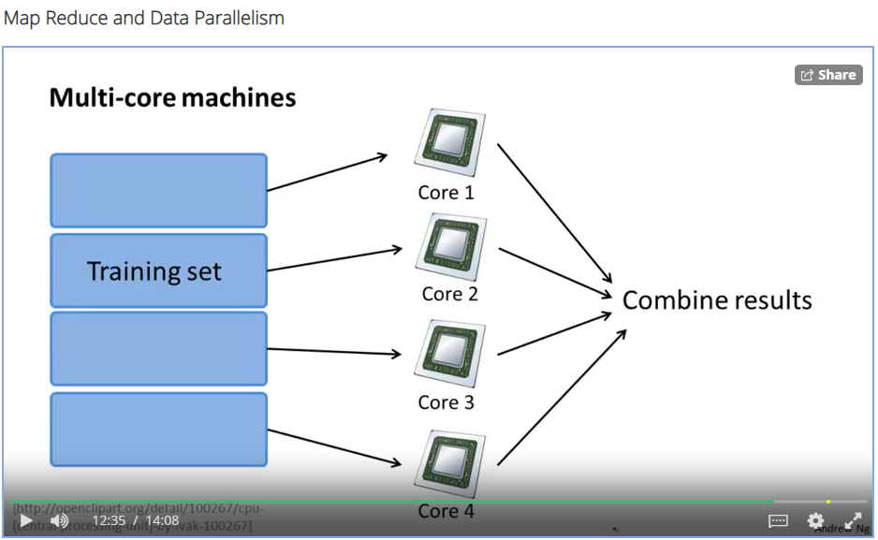

Aah ! This is the methodology they use for data privacy of training data in case of personal devices generating those data. Such as pictures, documents etc. so the thing is our personal shall use their own personal processing power just to learn the data in that device and further this learning is aggregated ahead in a centralized system to give a combined result !!

**Week 11:**

**Fact/good to know:**

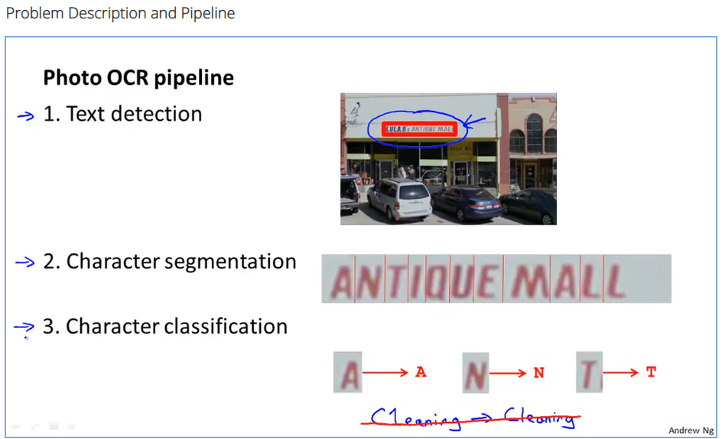

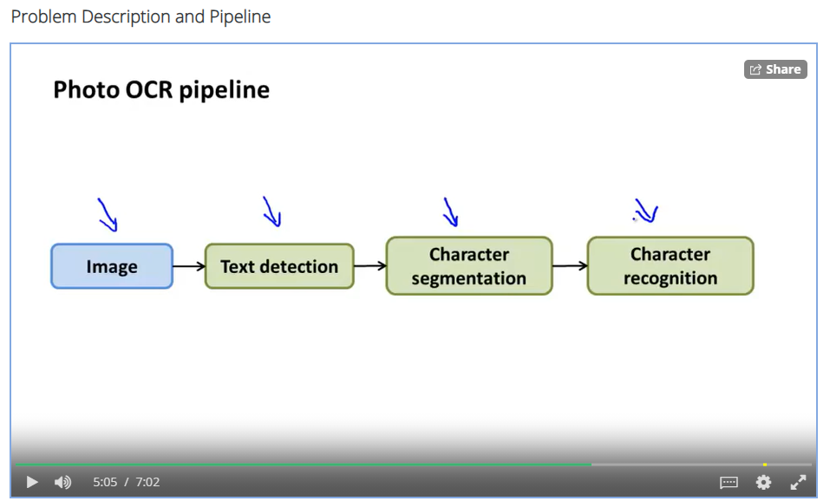

Usual pipeline for a character detection algorithm in a digital photo.

**Week 11:**

**Fun** .**occurrences:**

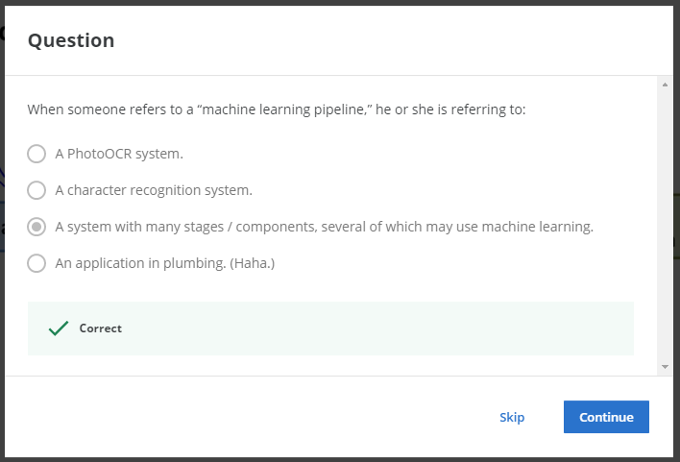

Look at the 4th option !! Haha ! :P

**Week 11:**

**Fact/Good to know:**

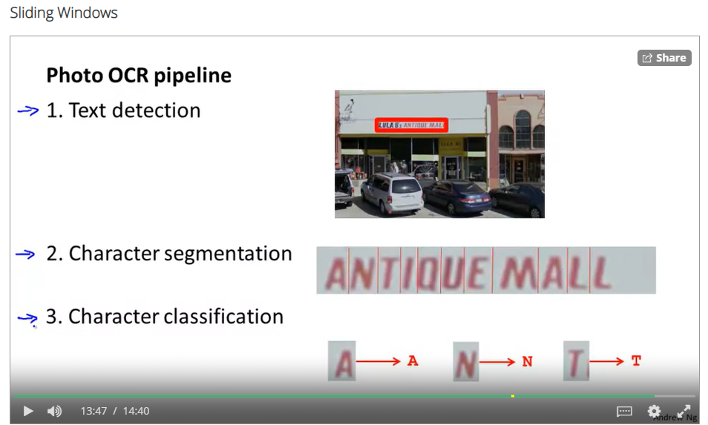

**Week 11:**

**Fact/Good to know:**

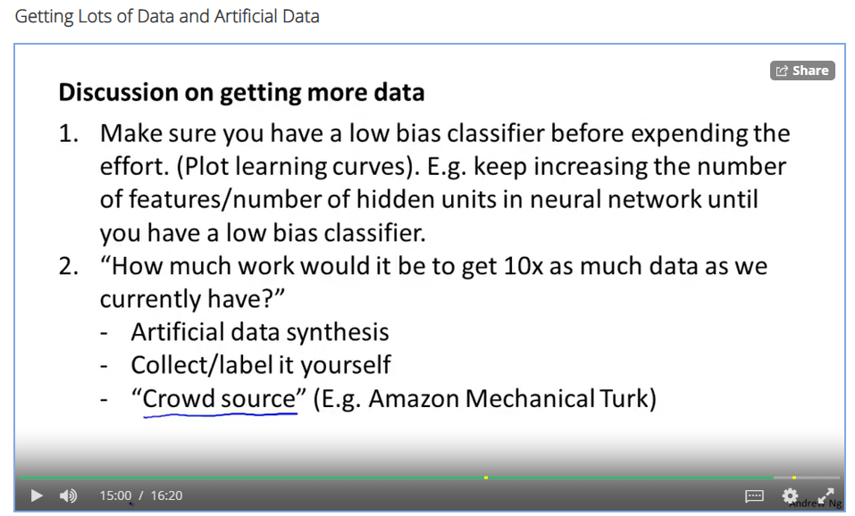

**Week 11:**

**Fact/Good to know:**

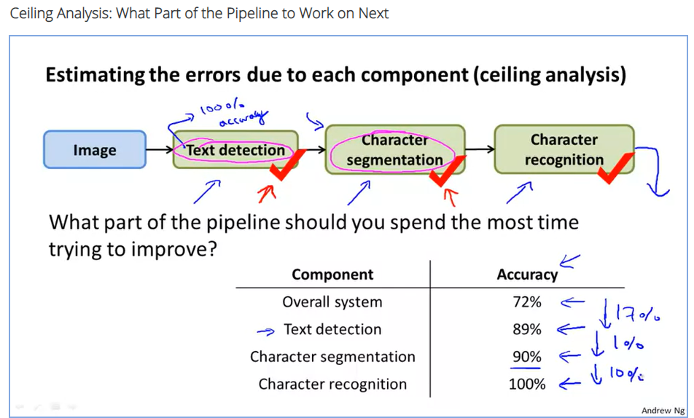

Like someday when we make a beeg pipeline for a machine learning application, we should know from this where to look for improvement.

**Final note**



